KYLE ANTHONY F. NIOSCO  
BSCS | CP102 (MW, 7:30 – 9:00, 4:00 – 5:00)  
DR. JOSE TAN JR.  
MAY 2020

* TABLE STRUCTURE

The screenshot shows the structure of the table that was created in the database **studentdb**. The requirements such as id, Student Number, Last Name, First Name, Middle Name, Birthday, Age, Address are all there in **tblstudent**.

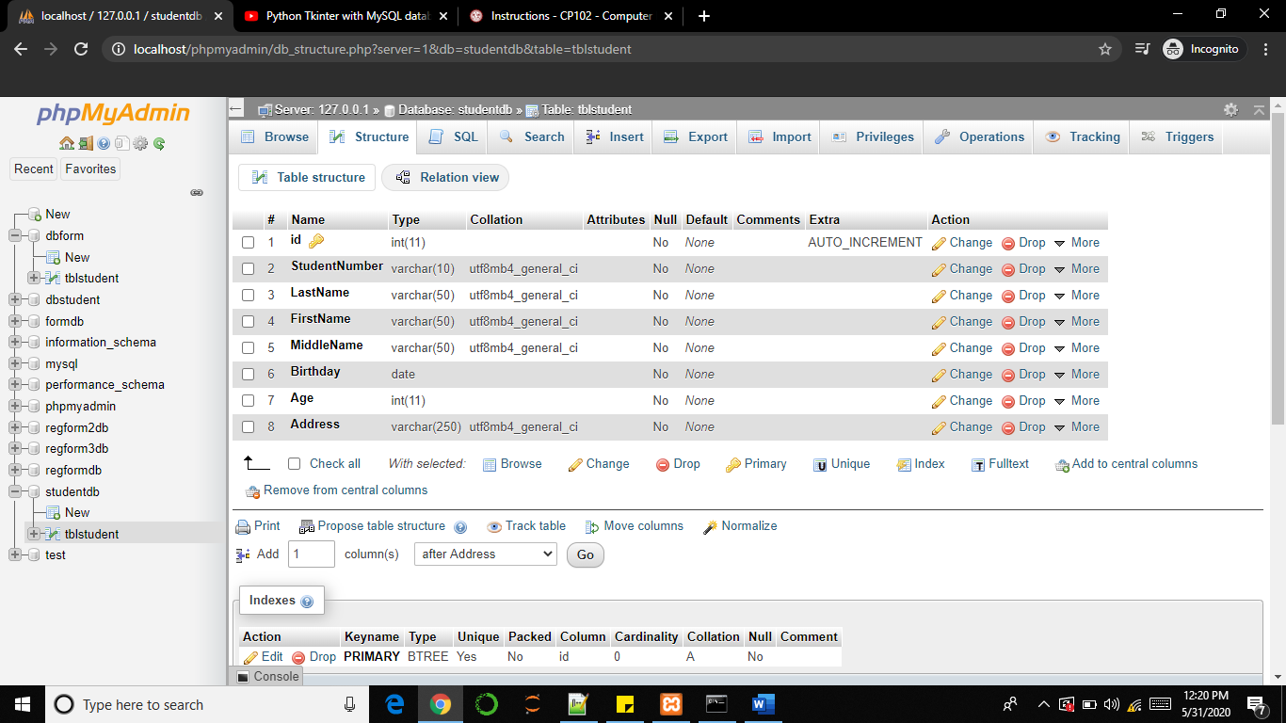

* TABLE CONTENT BEFORE DELETING AND EDITING  
This shows the contents of the table which are collected from filling out the form, in which the information is inserted into the database.

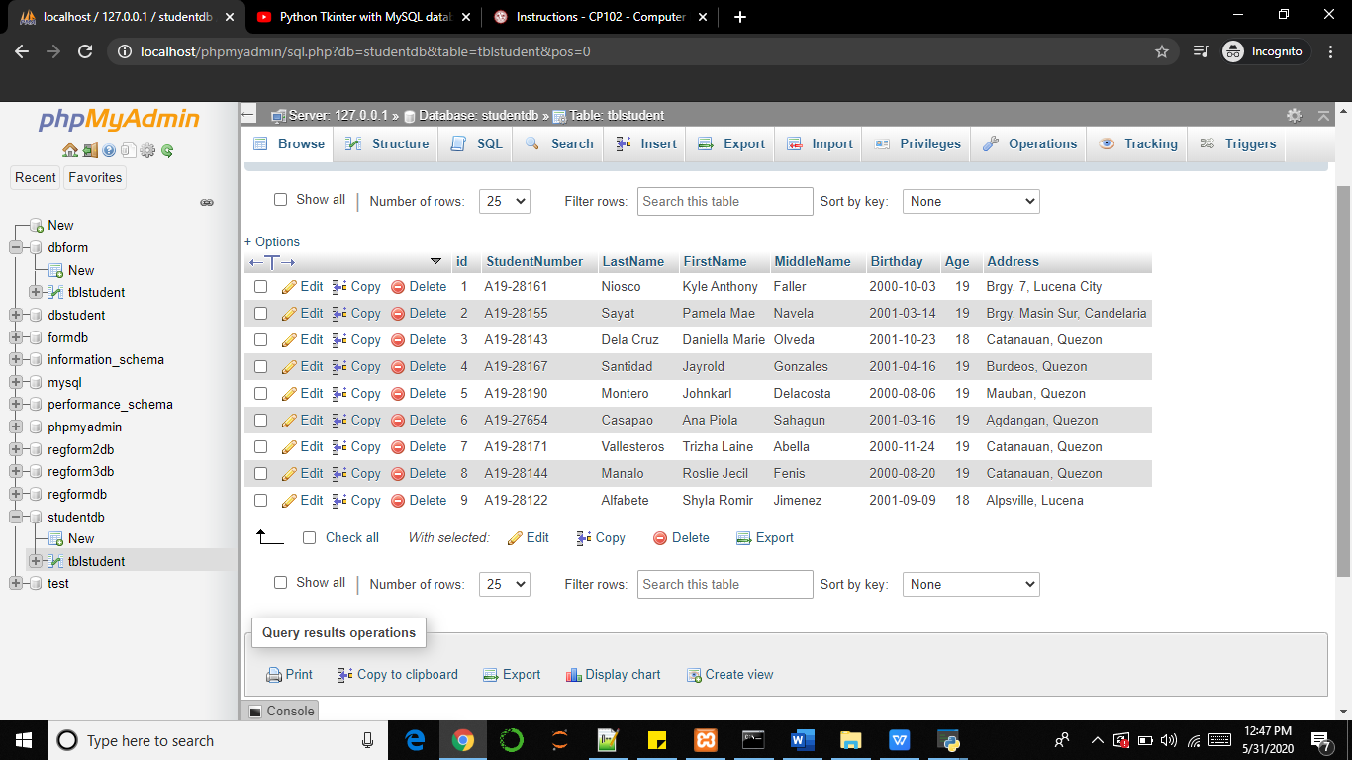

* TABLE CONTENT AFTER UPDATING (editing and deleting)  
This shows the table contents after it is updated through the edit and delete functions.

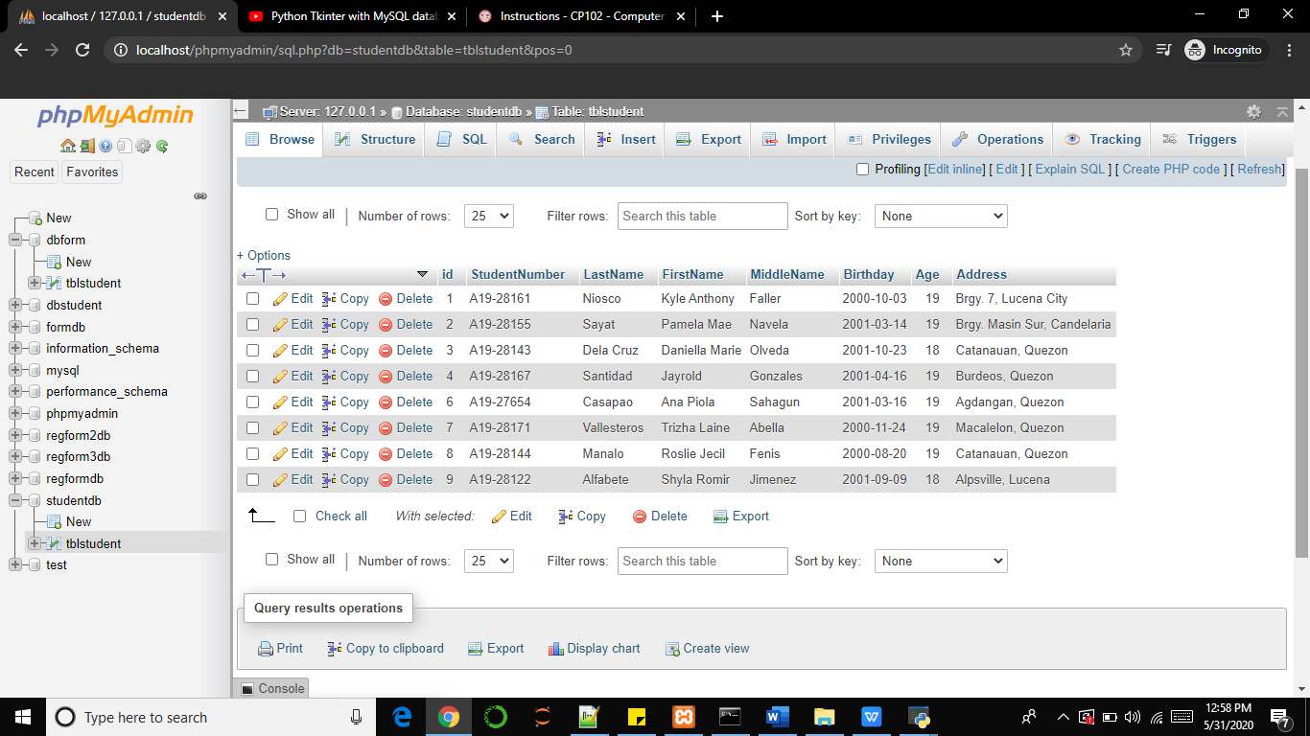

* OUTPUT of **final.py** file

When you run this program, a window will pop-up which shows a registration form of the user. The user has to input his information in the fields required in the form.

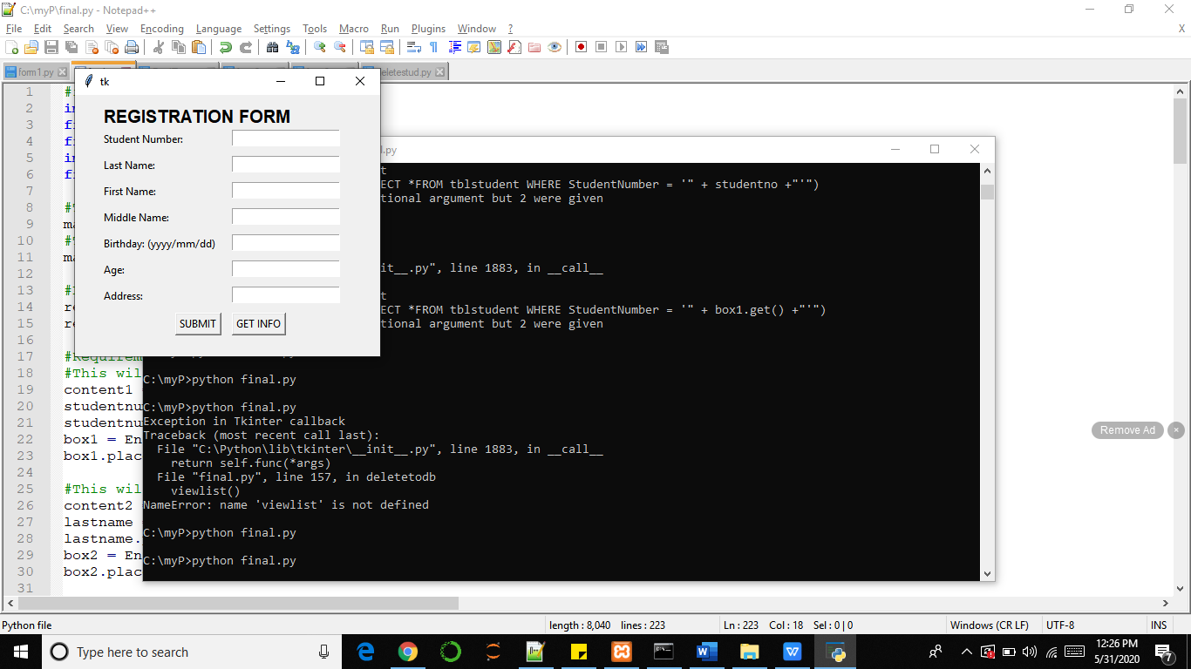

After clicking SUBMIT button, another window will pop up, in which you will confirm your submission.

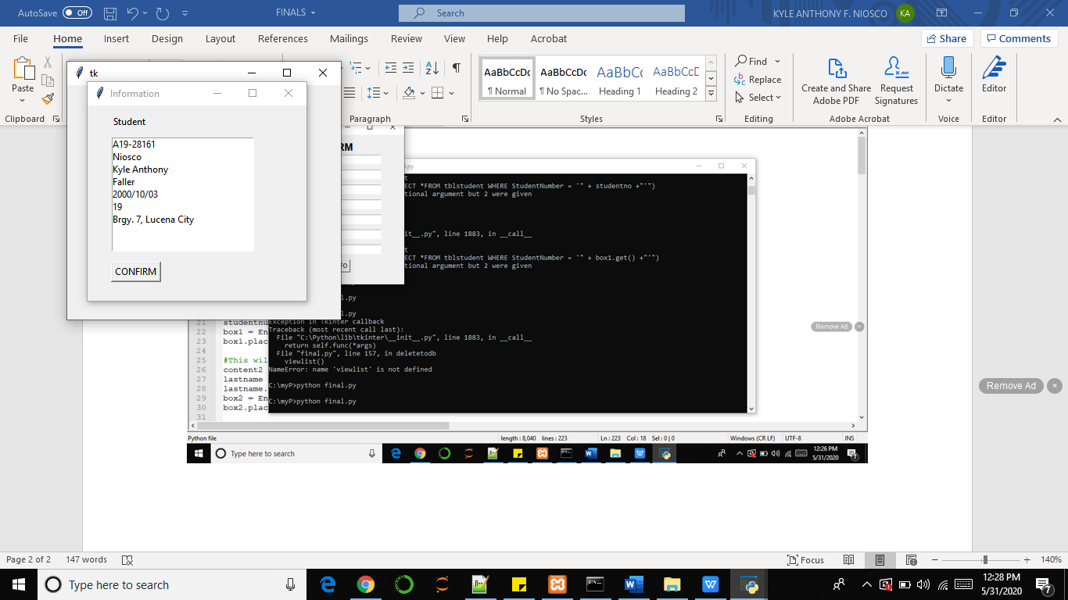

After confirming, this output will be shown which says that you had successfully submitted your information.

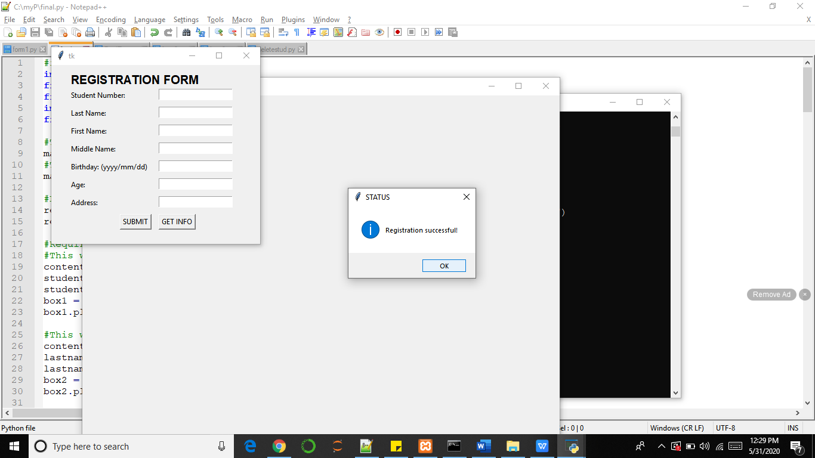

After clicking OK button, the registration form will stay there with blank fields for the user to input another set of information and the list of the students who filled out the form will be shown.

This is the output after inputting information.

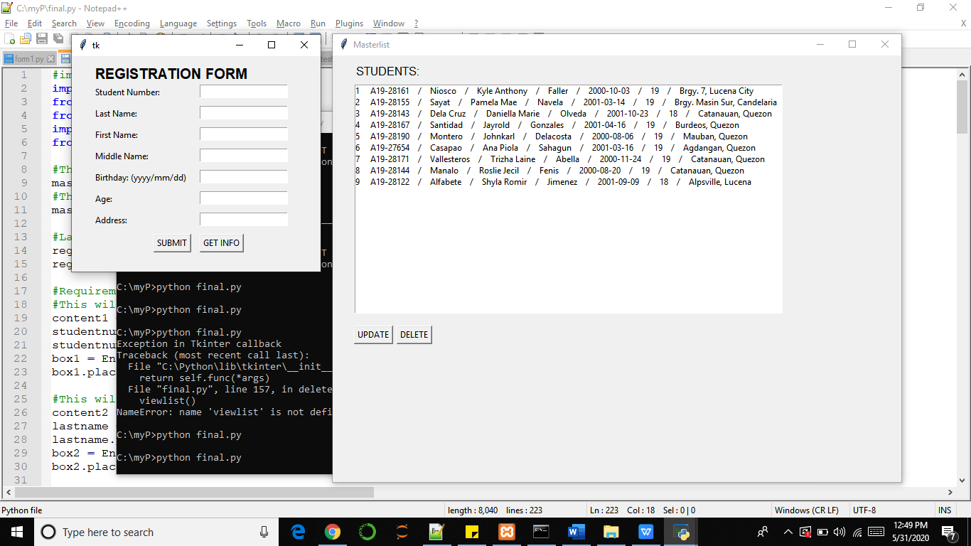

Then, there are UPDATE and DELETE buttons under the listbox. If you wish to update a certain information, you need to put the Student Number of your choice then click GET INFO. This is what will happen.

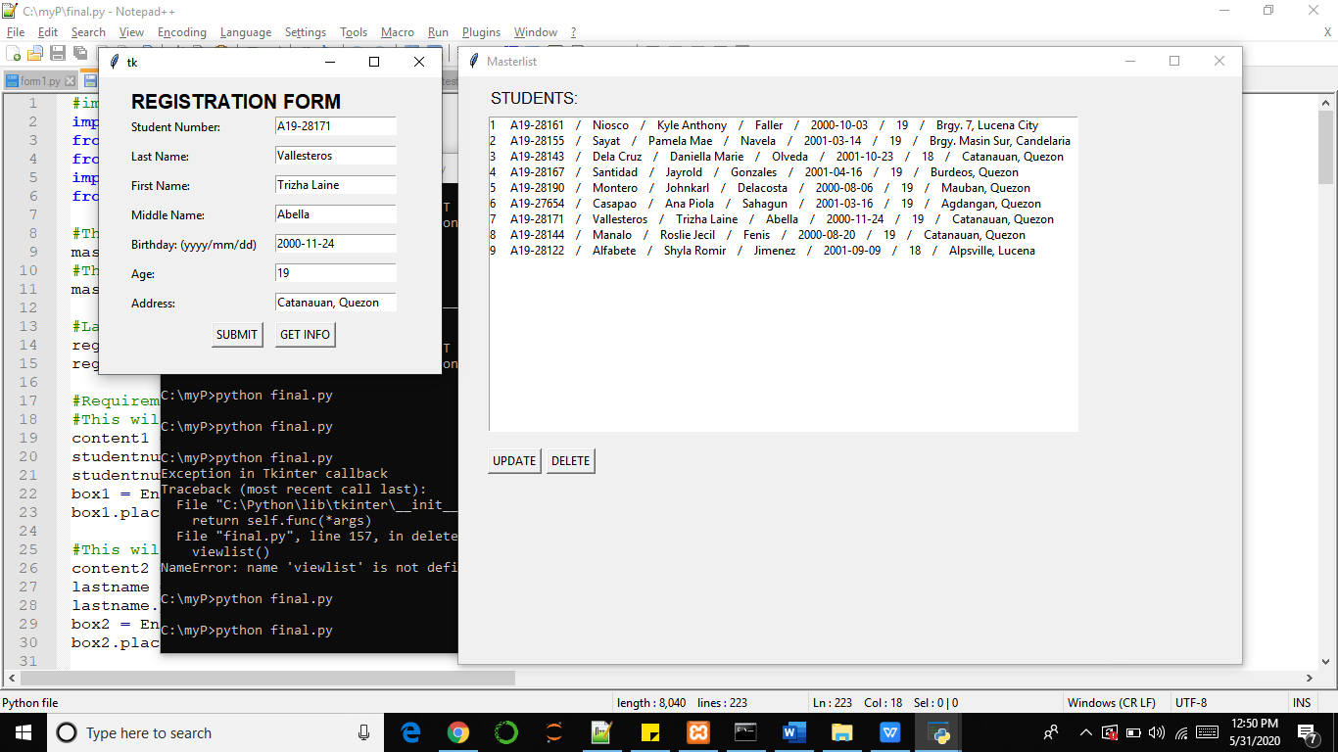

You can now edit the information of your chosen record. After editing, click the UPDATE button and the output will be shown in the screenshot after this statement.

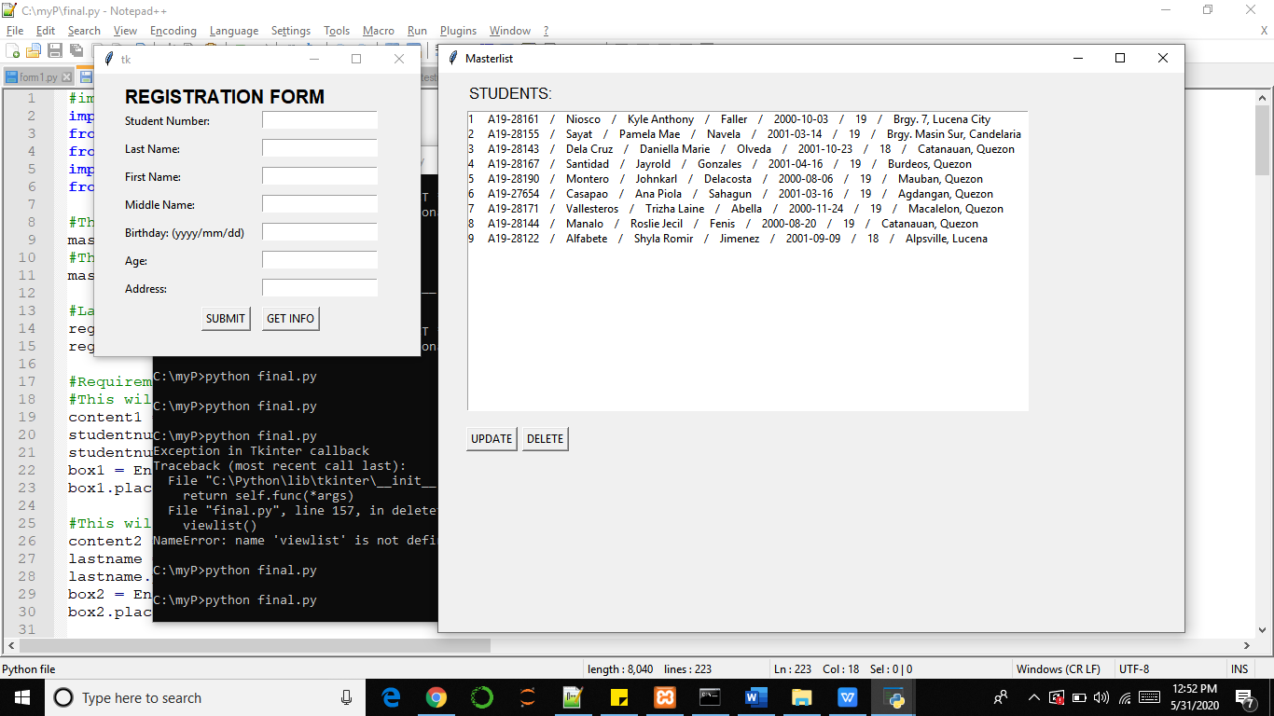

The Address was changed from Catanauan, Quezon to Macalelon, Quezon.

Now, if you wish to delete a certain record, you will do the same by getting the information of your chosen one to delete. You just have to type the Student Number of your choice and then click GET INFO. After that, click the DELETE button. This is what happened when I delete the information of id # 5.

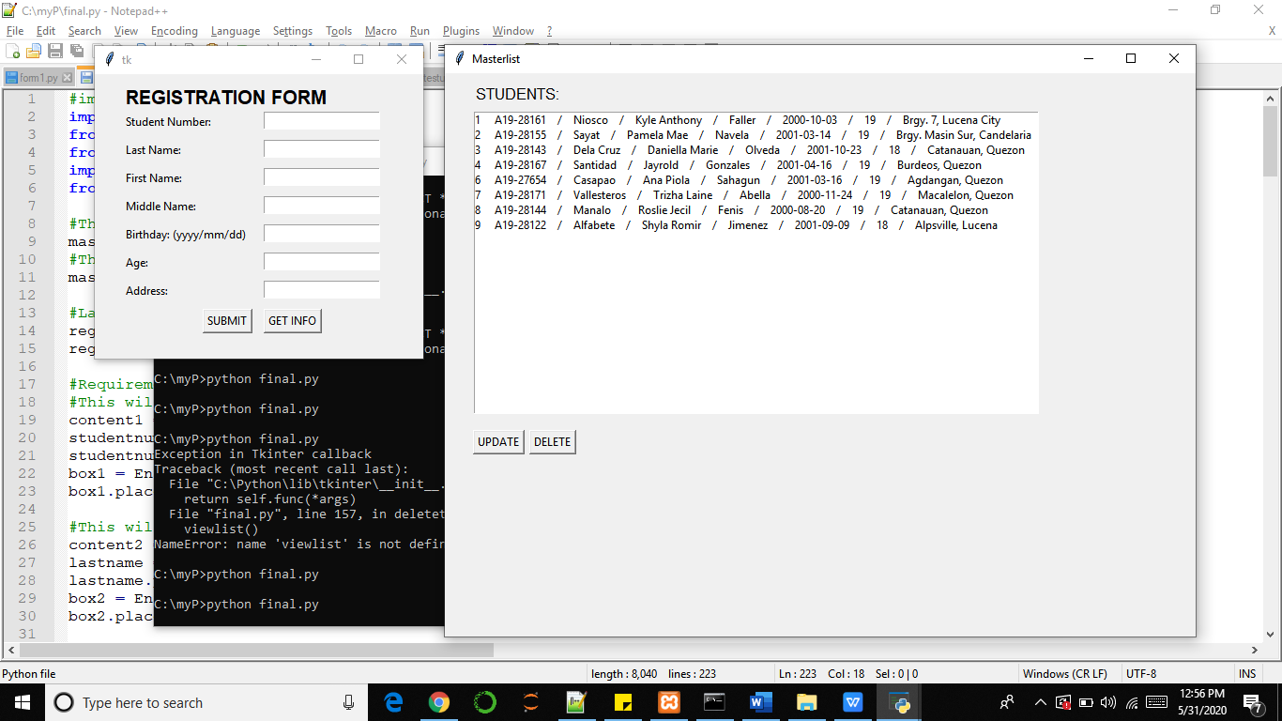

THE RECORD OF ID # 5 IS ALREADY GONE AFTER DELETING IT.

That’s how the UPDATE and DELETE function in my program.